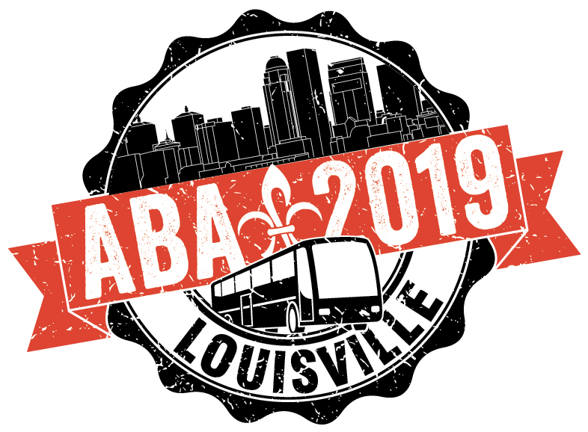

American Bus Association 2019 Marketplace

In January of 2016, the city of Louisville and the State of Kentucky hosted the most highly attended American Bus Association Annual Marketplace in the 40 year history of the event! ABA Marketplace is the premier group tour industry tradeshow and business event with over 3,500 in attendance including 925 motorcoach owners and operators and over 2,000 representatives from more than 2,500 destinations, hotels, attractions and restaurants.

After receiving rave reviews and record attendance for the 2016 Marketplace, Louisville Tourism won the bid to host the American Bus Association again from January 26-29, 2019.

We need YOUR help to make the ABA Marketplace 2019 better than when we hosted it in 2016 by VOLUNTEERING with us! Please visit our volunteer registration website (or download the app), www.app.mobileserve.com/login and create your profile. Once you enter our special organization code ABALOU, you will be privy to all the exclusive volunteering opportunities. Training will be provided and is available to sign up for on this site.

Please contact Rose Caple at rcaple@gotolouisville.com (502.814.2746) with any questions and THANK YOU for volunteering!

