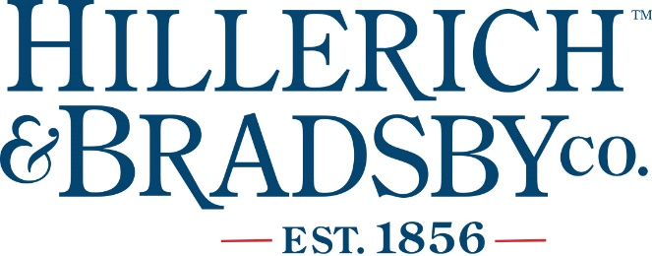
Position: General Manager-Barrels & Billets
FLSA Status: Exempt
Location: Louisville, KY
Reports to: Director of Guest Experience, Louisville Slugger Museum & Factory
Reporting to
this Position: Assistant Manager(s) for Bourbon Experience FT (1-2), Experience Lead FT (1-2), Team Members PT (6-20)
Position Summary:

Responsible for all aspects of inventory control and process adherence. Ensures overall quality of guest experience for Barrels & Billets Custom Bourbon Experience is at the highest standards at all times. Liaison with WoodCraft partners to ensure H&B strategy, operations, and brand elements are in line with contractual agreement. Develop and maintain relationships with hotels, restaurants, and bars to market experience and product. Plan and manage daily operation of custom bourbon experience including leadership of staff, scheduling, calendar of activities/events, and retail merchandising and inventory. Coordinate recruiting, hiring, training, and development of Assistant Manager(s) and part-time team members. Develop, track, and report on budget for entire experience to ensure revenue and expenses are in line. Work closely with H&B Marketing Director and Sales Director by providing active leadership in the development and implementation of marketing and sales strategies. Position requires night and weekend work.
Essential Functions:

- Ensure world-class guest experience and business operations in every facet of custom b bourbon attraction while maintaining relationship with WoodCraft partners.

- Lead, manage, and develop all direct reports, holding team members accountable to high standards.

- Ensure production and bottling processes are following all standard operating procedures.

- Get out in the community to market and sell custom bourbon as well as luxury brands.

- Create schedules that ensure offerings and staffing are commensurate with attendance and sales goals and adjust as needed to keep labor costs on track.

- Collaborate with H&B team and WoodCraft, provide active leadership in the development and implementation of content for all B&B experiences including educational experiences at the teaching bar, presentations, and shorter experiences for walk-up guests.

- Work closely with marketing, sales, and operations leadership to develop, implement, and improve strategies, processes, marketing plans, and sales goals.

- Oversee functionality of POS systems including but not limited to retail POS, scheduling and ticket sales software, and inventory management systems.

- With team, create and enforce all written policies consistently.

- Responsible for planning, execution, and analysis of operational flow for custom bourbon experiences.

- Coordinate and lead the recruiting, hiring, onboarding, and training process for new front-line employees.

- Conduct ongoing analysis of attendance, sales, budgets, and experience offerings and adjust as needed.

- Oversee all facility-related aspects of bourbon experience, including safety/security, general maintenance, and custodial.

- Oversee all back-of-house operations and strive for continuous improvement of processes as they relate to bottling and shipping.

- Work closely with Assistant Manager(s) and bourbon partners on the creation and execution of new ideas as they relate to bourbon blending experiences.

- Research and select partners for operational business needs and negotiate agreements with facility-related contractors.
Other Duties:
Work nights and weekends as needed. Performs other job-related duties and responsibilities as assigned.
Requirements:
- Bachelor’s Degree
- Minimum 5 years experience in attractions, hospitality, or spirits
- Experience with start-up businesses beneficial but not required
- Experience with sales and marketing
- Knowledge of bourbon beneficial but not required

