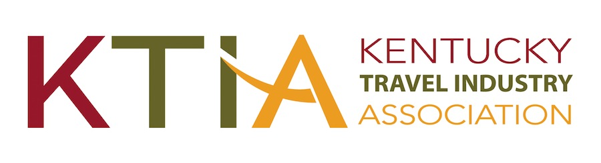
For more information, contact
Hank Phillips, President/CEO at (502) 223-8687
Hank.Phillips@ktia.com
931 East Main Street
Frankfort, Kentucky 40601
Ph. (502) 223-8687

FOR IMMEDIATE RELEASE

(Organization) Wins Prestigious Tourism Award(s)

Frankfort, KY (November 16, 2018) - (Organization) has received a Traverse Award for Excellence in Tourism Marketing from the Kentucky Travel Industry Association. The award was presented on Wednesday, November 14 during the Traverse Gala Awards Dinner held at the Owensboro Convention Center as part of the 2018 Kentucky Travel Industry Annual Conference.

(Organization) received a (Level(s)) Traverse for its (Name or description of entry). According to, (Organization’s spokesperson), “(Comments).”

Kentucky travel and tourism businesses and marketing organizations vie for Traverse Awards in 12 categories during the annual competition. The Traverse Awards are judged by a panel of out-of-state travel and tourism industry experts. Award criteria include concept, creativity, results and impact. Over 150 entries were submitted from throughout Kentucky for the 2018 competition.

According to KTIA President/CEO Hank Phillips, “The Kentucky travel and tourism industry includes some of the most creative and effective marketing professionals to be found in any state and in any industry. It is that creativity and marketing that has resulted in tourism becoming one of Kentucky’s premier economic drivers. Traverse awards are much sought after and prestigious acknowledgements of success within this highly skilled industry.”

The Kentucky Travel Industry Association represents and serves all segments of Kentucky’s over $15 billion tourism industry. The industry supports 196,000 Kentucky jobs and generates $1.57 billion in local and state tax revenue. The 830-member association engages in advocacy and provides its members with education, information and business development opportunities. The association also works to inform the public of the enormous economic, employment and tax revenue contributions tourism makes to Kentucky.

