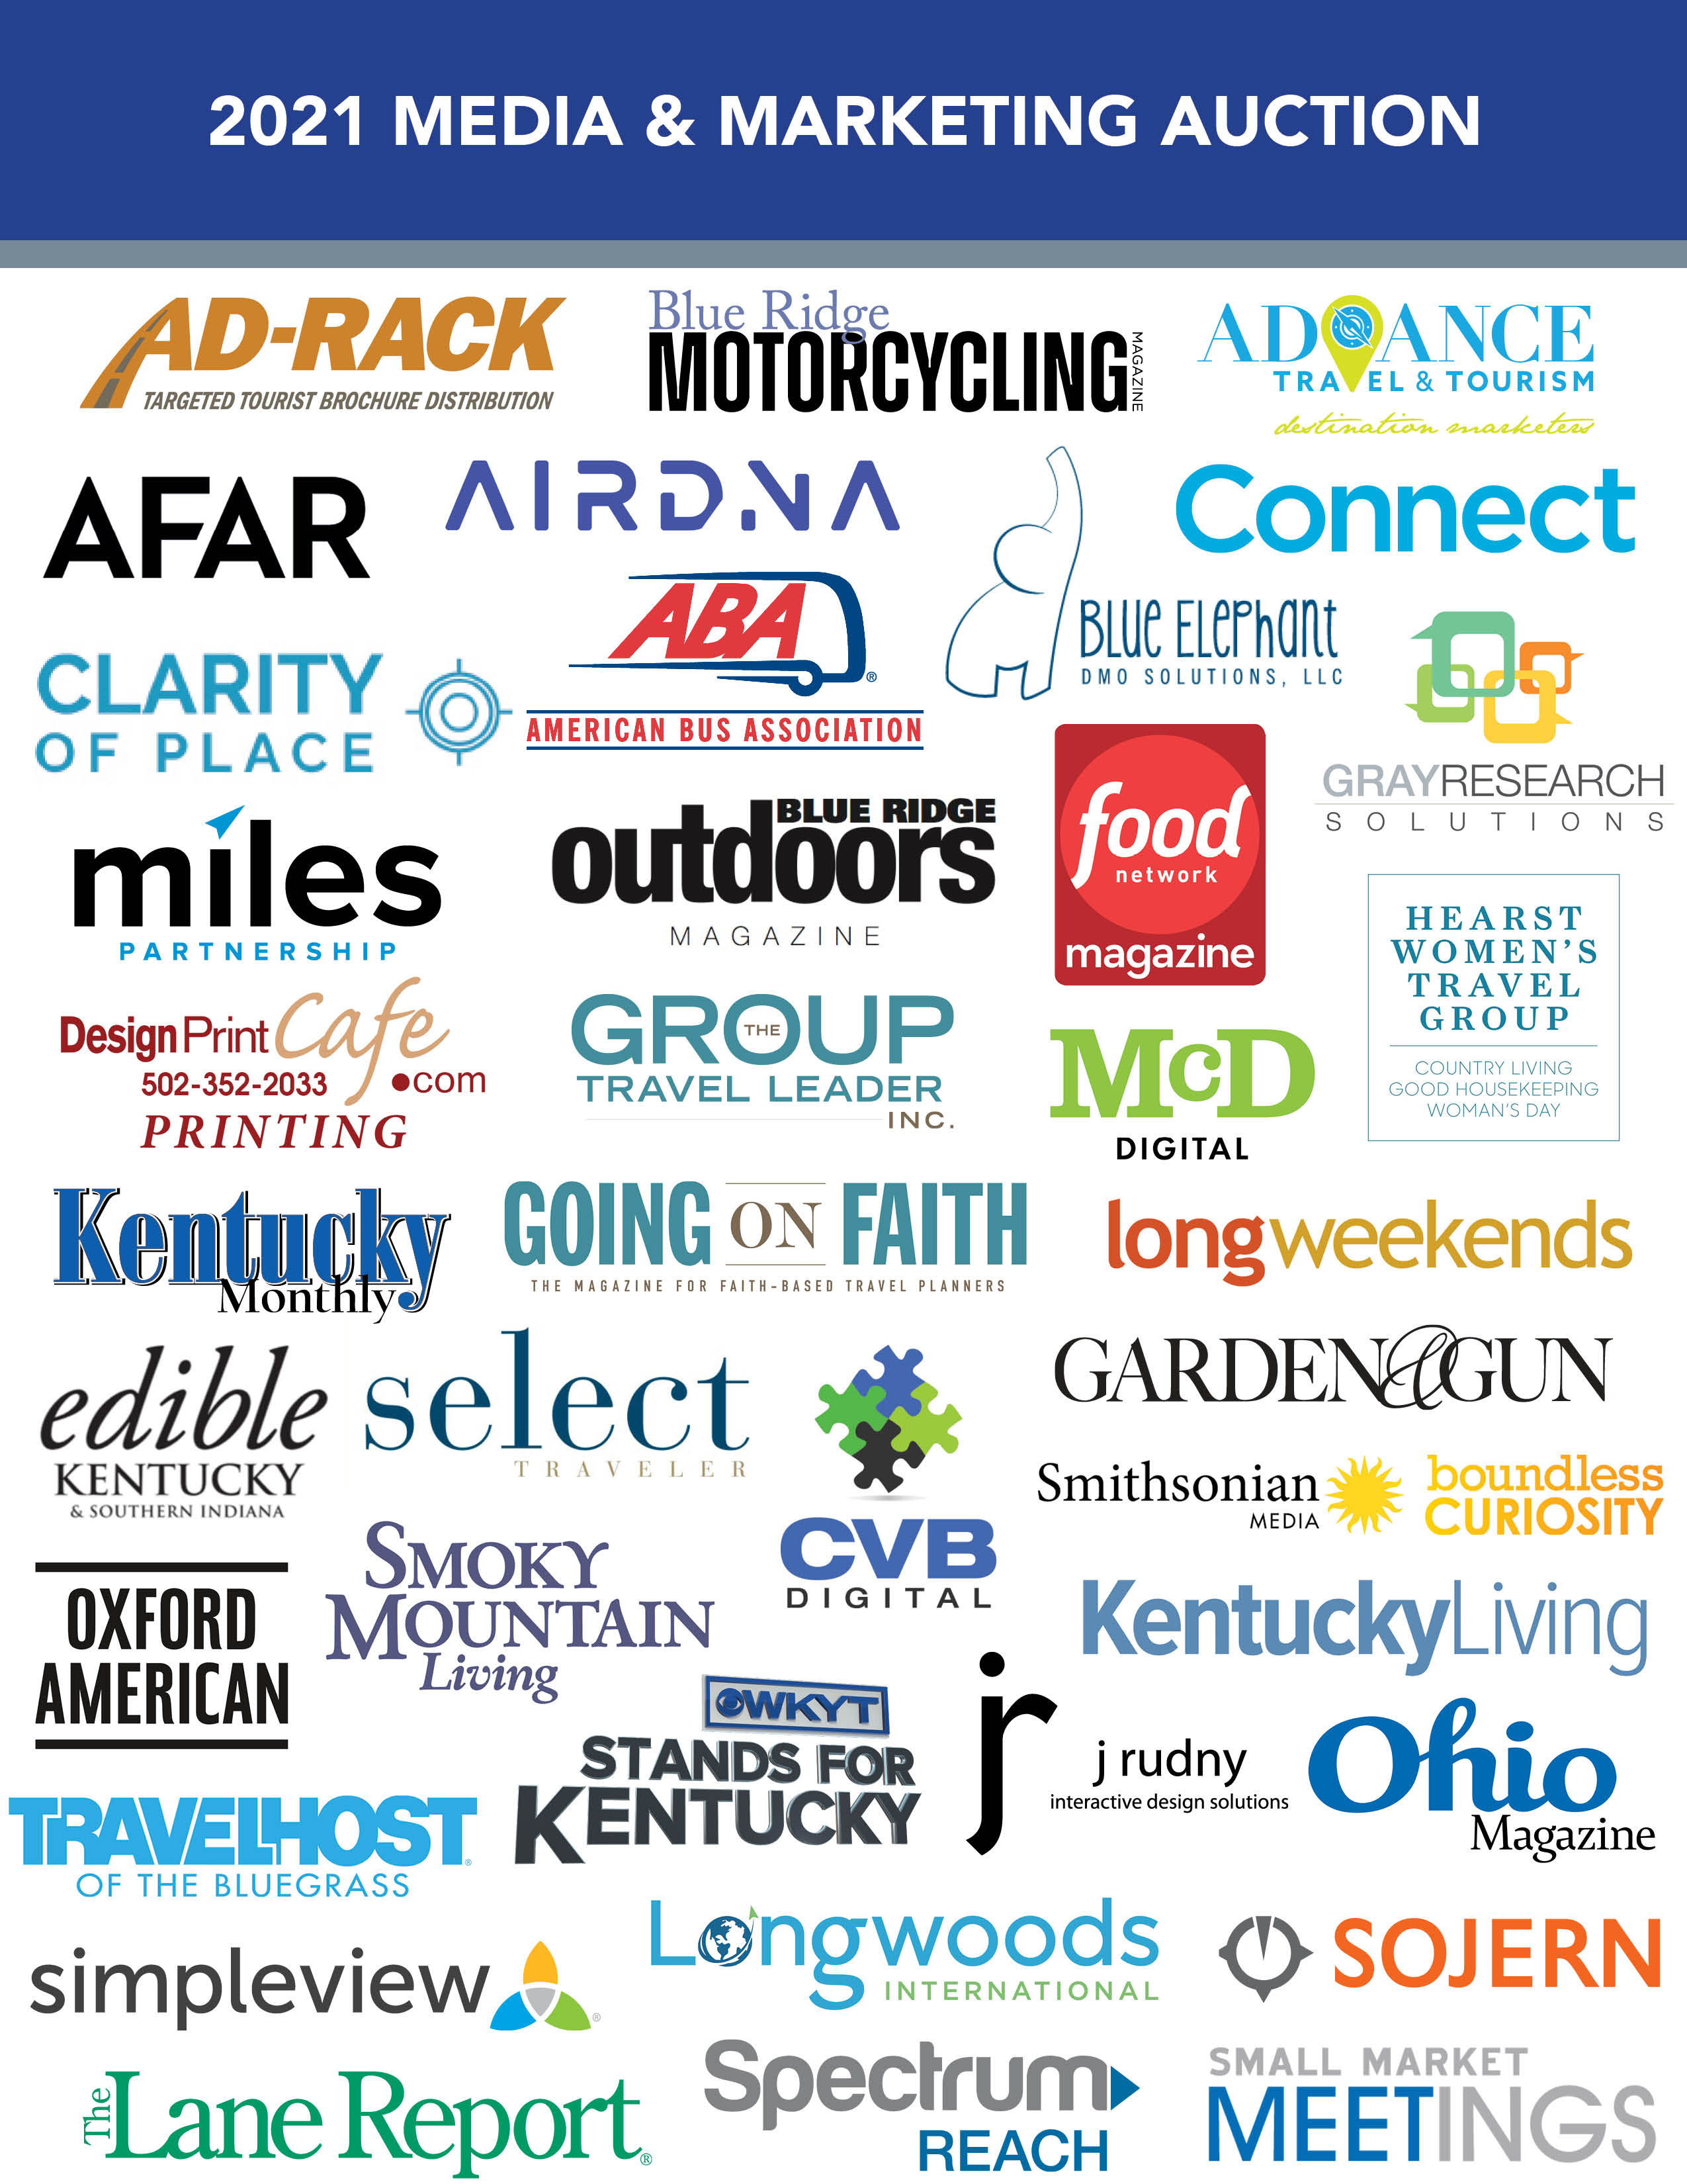

**[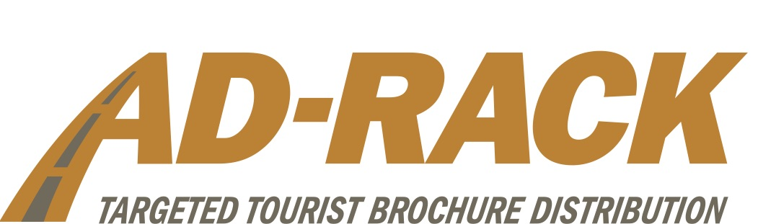](http://www.ad-rack.com/)**

**AD-RACK**

*Value: $1,400 • Minimum Bid: $550*

**ITEM**:

Six months distribution* (single/brochure size pockets) in 6 Kentucky Rest Areas of your choice.

*For new customers or current customers not presently in the Rest Area service. (Distribution to begin by Oct. 1, 2021) Brochure must be for a Kentucky attraction.

Joyce Bryant

Phone: 502-253-5454

Email: [joyce@ad-rack.com](mailto:joyce@ad-rack.com)

**[](https://www.advancetravelandtourism.com/)**

**ADVANCE TRAVEL & TOURISM**

*Value: $3,000 • Minimum Bid: $1,000*

**ITEM:**

30-day digital advertising blitz

**ITEM DETAILS**:

Blitz targeted in Nashville, Atlanta or Birmingham (300,000 display ad impressions delivered on our nationwide network of websites, behaviorally targeted to Travel Intenders, Road Trippers Enthusiasts, Families Who Love to Travel, Millennials, History Buffs, Boomers, etc. Includes campaign reporting). Must use by 12/31/21.

***ABOUT ADVANCE TRAVEL & TOURISM:***

*We’re a team passionate about destination marketing, data, storytelling and all things digital.*

*Advance Travel & Tourism works with travel partners across the US: from Portland, Oregon to Portland, Maine – giving us key insights and learnings that apply to the programs, products and content we produce for destinations, just like you. Our hands-on approach ensures we understand your needs and creates a solution that meets your goals and budget. We’re committed to the travel industry – as members of VRMA, STS, and consistent supporters, presenters and attendees for state tourism conferences – we’re deeply rooted in the industry we serve.*

*Jacquelyn Blackwell*

[*JBlackwell@al.com*](mailto:JBlackwell@al.com)

*334.201.0531*

*Will Crockett*

[*JCrockett@al.com*](mailto:JCrockett@al.com)

*615-210-7986*

[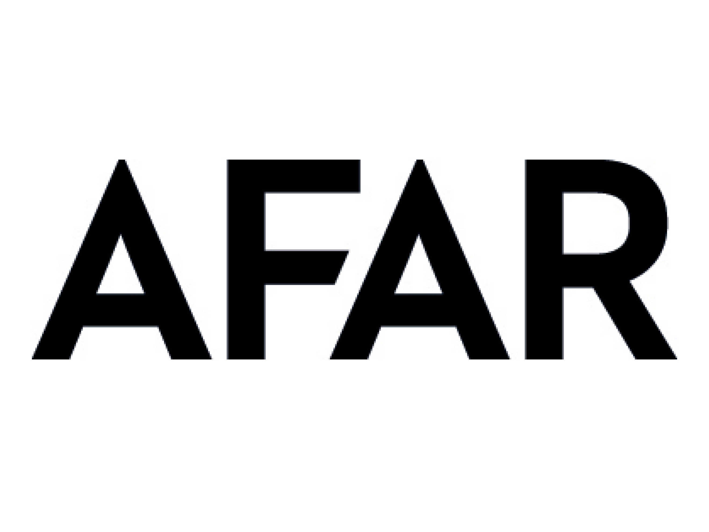](https://www.afar.com/)

**AFAR**

*Value: $3,500 • Minimum Bid: $1,100*

**ITEM:**

Wanderlust Email Blast

**ITEM DETAILS**:

This exclusive email blast delivers your custom message to AFAR’s most engaged and active audience. Content may include a special offer and can drive recipients to your website or sponsored content on [AFAR.com](http://afar.com). The email blast can be geo-targeted or interest-targeted. AFAR will design the email blast based on supplied copy and images. [Example Here](https://email.afar.com/view/5d76790e05e94e77034382aacazyh.1/e96806a0)

* Reach: 5,000/email
* Booking: please book 30 days in advance, deployment date based on availability.
* Material Requirements: 1 - 3 brand messages. Each brand message requires: hero image (horizontal, 600px), headline, 50 words of copy, brand logo, and URLs

***ABOUT AFAR:*** *AFAR believes that travel can change the world.*

*AFAR is the world’s leading travel media brand that inspires and guides travelers to have deeper, richer, and more meaningful experiences. We value a deep sense of cultural immersion and exploration and have been recognized for our vibrant and authentic travel photography. We don’t shy away from presenting places as they really are and we celebrate global diversity in all forms. Our brand platforms include the award-winning AFAR Magazine,*[*AFAR.com*](http://AFAR.com)*; our nonprofit Learning AFAR, and our immersive travel series, AFAR Experiences.*

*Colleen Schoch*

*561 350-5540*

[*Colleen@afar.com*](mailto:Colleen@afar.com)

**[](https://www.airdna.co/)**

**AIRDNA**

*Value: $1,500 • Minimum Bid: $600*

**ITEM:**

Short-Term Rental (STR) Deep Dive.

**ITEM DETAILS**:

Includes 1-hour consultation session on the Airbnb/Vrbo market in YOUR destination (city or county) with AirDNA's Head of Real Estate.  Includes a one-off Market Summary Report with 5 years of history on the number of listings, supply/demand, ADR, and other key data points.

***ABOUT AIRDNA:***

*AirDNA turns short-term rental data into strategic, actionable analytics. As the world's leading provider of short-term vacation rental data and analytics, we track the daily performance of over 10 million listings in 120,000 markets globally on Airbnb, Vrbo, and more. Destination marketing organizations, Airbnb hosts, vacation rental managers, hoteliers and real estate investors all rely on AirDNA’s vacation rental insights to better understand the STR market, optimize their listings, find lucrative properties, and outperform the competition. AirDNA empowers our customers with the data to set them apart, and the insights to keep them ahead.*

*Kellen Kruse  
Director of Business Development*[*kellen.kruse@airdna.co*](mailto:kellen.kruse@airdna.co)

*310-663-8447*

**[](https://www.buses.org/)**

**AMERICAN BUS ASSOCIATION**

*Value: $580 • Minimum Bid: $150*

**ITEM:**

1-year membership for the American Bus Association or renew one year and get the next year free for current members. (Operator Membership is good through June 30, 2022 and Travel Membership is good through December 31, 2022.)

***ABOUT ABA:***

*In 2021, ABA celebrated its 95th anniversary. The association continues to grow and adapt to the changing needs of the industry and looks forward to the next 95 years serving the group travel and tourism industry.*

*Lia Zegeye, M.S.  
Senior Director of Membership*

*American Bus Association*

*Office: 202.218.7234*

[*www.buses.org*](http://www.buses.org/)

[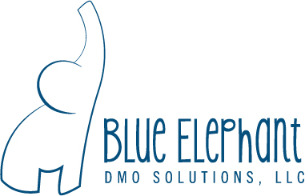](https://blueelephantsolutions.com/)

**BLUE ELEPHANT DMO SOLUTIONS**

*Value: $1,500 • Minimum Bid: $600*

**ITEM**:

Board training

**ITEM DETAILS**:

Blue Elephant DMO Solutions will conduct Board Training to educate the board on:

* The importance of tourism
* The role of the DMO in a community
* The responsibilities and role of the DMO board
* The role and responsibilities of the DMO President/CEO

*Travel not included.

*Dawn Przystal*

*President*

*Blue Elephant DMO Solutions*

[*dawn@blueelephantsolutions.com*](mailto:dawn@blueelephantsolutions.com) *502.507.4715*

[*www.blueelephantsolutions.com*](http://www.blueelephantsolutions.com)

**[](https://blueelephantsolutions.com/)**

**BLUE RIDGE MOTORCYCLING MAGAZINE**

*Value: $795 • Minimum Bid: $400*

**ITEM**:

1/3 page ad (Expires 6/30/2022)

***ABOUT BLUE RIDGE MOTORCYCLING MAGAZINE****:*

*Blue Ridge Motorcycling Magazine, is a quarterly, luxury, lifestyle magazine embracing the beauty of the Blue Ridge Mountains. Each issue explores several places to ride, biker friendly breweries and a restaurant review.  The magazine is distributed by both paid subscribers and newsstands sales in the 7-state region (Georgia, North/South Carolina, Tennessee, Kentucky, Virginia and West Virginia).*

*Circulation 10,000 copies; paid subscribers and newsstand sales. Affluent motorcyclists who love to ride. Mid-Atlantic and Southern States*

*Lisa L. Williams*

*Advertising Sales Rep*

*Smoky Mountain Living Magazine/Blue Ridge Motorcycling Magazine  
865-742-4388 - cell*[*lisa.w@smliv.com*](mailto:lisa.w@smliv.com)[*facebook.com/smokymtnliving*](http://facebook.com/smokymtnliving)[*twitter.com/smokymtnliving*](http://twitter.com/smokymtnliving)

**[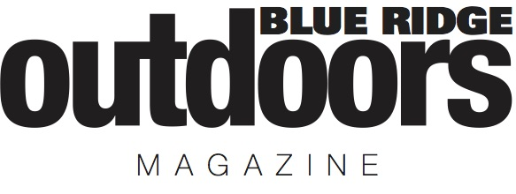](https://www.blueridgeoutdoors.com/)**

**BLUE RIDGE OUTDOORS**

*Value: $3,800 • Minimum Bid: $1,200*

**ITEM**:

1/2 page ad

**ITEM DETAILS**:

1/2 page ad in the geo-targeted circulation of Blue Ridge Outdoors Magazine (full color/glossy). Ad may be placed in any non co-op month between August 2021 - July 2022  
***ABOUT BLUE RIDGE OUTDOORS****:*

*Blue Ridge Outdoors is the largest free outdoor lifestyle publication in the country.  Published 11 times a year with themes such as hiking, biking, top adventure towns, road trips, parks and more, Blue Ridge Outdoors is for people interested in outdoor recreation and adventure travel in the Southeast. Every month we inspire our readers to go outside and play with compelling stories and beautiful photographs of the region’s best outdoor playgrounds.  The outdoors are free and so are we--which ensures readers across the region within a day's drive of Kentucky--have access to the most engaging outdoor content available.*

* *Circulation: 75,000*
* *Subscriber Demographics: Active Outdoorsy Adults, Ages 25-54*
* *Distribution: Metro DC, Southwestern VA, WV, KY, NC, SC, TN, GA, AL*

*Leah Woody*

*Publisher*

*(434) 825-2055 (cell)*

[*leah@blueridgeoutdoors.com*](mailto:leah@blueridgeoutdoors.com)

**[](https://www.connectmeetings.com/)**

**CONNECT**

*Value: $6,000 • Minimum Bid: $1,900*

**ITEM**: Full page ad in one of Connect’s fall issues. Winner has the option to choose between Connect’s Association, Corporate, Faith & Sports publications.

***ABOUT CONNECT****:*

*In Connect’s print magazines, our focus is on our storytelling, not just on the ins and outs of meetings. Our talented editorial and design teams tell powerful, deep, reach-out-and-touch-your-soul stories that are complemented by beautiful visuals. We consider Connect a lifestyle magazine that happens to be read by meeting professionals, both on the planner and supplier side. A breath of fresh air in the industry, Connect provides content to enrich and enhance your travels and professional relationships.*

*Keenan M. Medlock  
Regional Vice President of Sales*

*C: 404.840.7013*

*E:*[*kmedlock@connectmeetings.com*](mailto:kmedlock@connectmeetings.com%22%20%5Ct%20%22_blank)

**[](https://cvbdigital.com/)**

**CVB DIGITAL**

*Value: $800 • Minimum Bid: $250*

**ITEM**:

CVB Digital Evaluation

**ITEM DETAILS**:

Improve your digital marketing and make your efforts more efficient. Start with a CVB Digital evaluation of your website, SEO, social media, Google My Business listing and Google Ads. We will help you to better understand what is working for you and what can use more attention, and what to spend less time on. We will advise you on optimizing for Google intent, voice-activated-search, social media influencers and reinvigorating your brand.

Our experts start with a call to gain a better understanding of your digital marketing goals and what makes your area a desirable place to visit. Then, we will review your website, SEO, social media and your Google Ads to evaluate how they are working together to deliver the intended results. At the end of the evaluation, we will deliver a written brief and action plan and during our phone consultation provide insights and answer your questions.

***ABOUT CVB DIGITAL****:*

*CVB Digital’s focus is helping small to mid-size CVBs become more effective in their use of digital marketing. We make your website, SEO, social media and Google Ads deliver better results. CVB Digital is not another advertising agency or website developer. We are digital marketing coaches, strategic advisors specializing in digital marketing for convention and visitors bureaus and destinations. Our services include in-depth evaluations, strategy improvement, easy-to-follow action plans and monthly coaching for you and your team. We help multiple Kentucky CVBs manage their Google Ads.*

*Ray Peabody*

*Your Digital Marketing Coach*

*678.860.3400*

[*ray@cvbdigital.com*](mailto:ray@cvbdigital.com)

[*CVBdigital.com*](http://cvbdigital.com/)

**[](https://ediblekentucky.ediblecommunities.com/)**

**EDIBLE KENTUCKY AND SOUTHERN INDIANA**

*Value: $800 • Minimum Bid: $250*

**ITEM**:

Quarter Page Placement in the upcoming Fall 2021 issue - our Annual focus on Beverages. Artwork due by Sept 1, 2021.

***ABOUT EDIBLE KENTUCKY AND SOUTHERN INDIANA****:*

*Edible Kentucky and Southern Indiana is a seasonal quarterly publication that promotes the growth and sustainability of local commerce; specifically, as it relates to food, beverage and overall well-being. Edible readers are among the most affluent, high educated, well-traveled citizens of the Commonwealth. We offer tourism marketers the 1) most clutter free, 2) well read, 3) long lasting, 4) locally focused publication available. Since its debut in March 2010, readers have come to trust Edible’s editorial voice, making Edible the perfect place for defining, strengthening, and connecting clients to your destination.*

*Steve Makela*

*Publisher*

*Edible Kentucky*

*P.O. Box 4820*

*Louisville, KY 40204*

[*stevemakela@gmail.com*](mailto:stevemakela@gmail.com)

[*ediblekentucky.com*](http://ediblekentucky.com)

**[](https://www.foodnetwork.com/magazine)**

**FOOD NETWORK MAGAZINE**

*Value: $6,250 • Minimum Bid: $1,700*

**ITEM**:

One space in our December Taste for Travel email blast.

**ITEM DETAILS**:

(Email Blast Materials: 3-5 word headline, 40 words of copy, URL, Logo, 1 jpg image (250x250))

***ABOUT FOOD NETWORK MAGAZINE’S TASTE FOR TRAVEL****:*

*Food Network Magazine’s quarterly Taste For Travel email blast goes to 50,000 opt-in subscribers.*

*Erin McDonnell*

*McDonnell Media Inc.*

*Southeast Sales Director*

*Toll Free: 888-410-5220*

*Office: 917-589-7533*

**[](https://gardenandgun.com/)**

**GARDEN & GUN**

*Value: $1,200 • Minimum Bid: $500*

**ITEM**:

Garden & Gun is happy to offer 75,000 run of site banner impressions on [Gardenandgun.com](http://gardenandgun.com) to run in 2021.

**ITEM DETAILS**:

Banner units we would need at 728x90, 300x250, 300x50 and 970x250.

***ABOUT GARDEN & GUN:***

* *Subscriber Demographics: Median Age 48, HHI $372k*
* *Distribution: National*

*Jana Robinson*

*Southeast Account Director*

[*jana@robinsonmedia.net*](mailto:jana@robinsonmedia.net)

**[](https://goingonfaith.com/)**

**GOING ON FAITH**

*Value: $1,040 • Minimum Bid: $350*

**ITEM**:

1/3 page 4-color ad (must use by July 31, 2022)

***ABOUT GOING ON FAITH****:*

*Going on Faith in the official magazine of the Going On Faith Conference and is America’s only magazine dedicated to the faith-based travel industry.  This quarterly magazine is read by more than 6,500 qualified travel planners for churches and religious groups.*

* *Circulation: 6,500*
* *Distribution: National*
* *Subscriber Demographics: Faith-Based Trade Partners*

*Kelly Tyner  
Vice President, Sales & Marketing  
The Group Travel Leader Inc.  
& Small Market Meetings  
859-334-1708*

**[](https://grayresearchsolutions.com/)**

**GRAY RESEARCH SOLUTIONS**

*Value: $5,000 • Minimum Bid: $1,500*

**ITEM**:

DMO Research Audit and Plan*

**ITEM DETAILS**:

Research helps understand what is working (or not) in your marketing strategies, helps you plan for the future, and serves as a defense for budgetary decisions. Yet many organizations are so overwhelmed with the data and analytics available to them that they don’t know where to start to make sense of it.

GRS will sit down with all the data, research, and analytics available to your destination to build an overall picture of tourism in your area. We’ll help you interpret what it means, what to track as KPIs in the future, and what insights are missing that you may want to consider investing in in the future.

Data sources may include but are not limited to:

* Tax records (state and local, where available)
* Lodging reports (Smith Travel Research, AirDNA, Key Data, etc.)
* Geo-location data (UberMedia, Arrivalist, etc.)
* Social media analytics (Facebook, Instagram, HootSuite, Sprout, etc.)
* Website Analytics (Google, etc.)
* Media buying reports
* Advertising/placement reports
* PR reports
* Research available from partners including state & regional tourism offices and local attractions/organizations

In the end, we’ll deliver a summary report of the insights we were able to uncover and a recommended plan for tracking and building on those insights in the future.

*\* To be used before March 1, 2022*

*\* DMO is responsible for collecting data from partners*

***ABOUT GRAY RESEARCH SOLUTIONS****:*

*Gray Research Solutions specializes in custom-designing research programs and studies that fit our clients’ goals and resources. We gather data and deliver insights on visitor profile and segmentation, brand image and reputation, ROI and economic impact, local lodging trends, and tourism overall. But more importantly, we specialize in making sense of all of that data so that our clients understand what it all means and can do something about it.*

*Our roots are in anthropology, the study of people and human behavior. Because of that, our perspective translates your constituents and visitors into living, breathing people who make decisions based on complex sets of reasoning resulting in complex sets of behavior. We simplify all this behavior and motivation down to the insights that matter most, so that you can create the marketing strategies that will bring you from good to great.*

[*www.grayresearchsolutions.com*](http://www.grayresearchsolutions.com)

*Shannon Gray*

*President/CEO*

*615.925.1304*

[*Shannon@grayresearchsolutions.com*](mailto:Shannon@grayresearchsolutions.com)

**[](https://www.greatgetawaysguide.com/hotdata/publishers/greatgetaways/greatgetaways/pdf/HWTG-MediaKit-8.pdf)**

**HEARST WOMEN’S TRAVEL GROUP**

*Value: $2,030 • Minimum Bid: $500*

**ITEM**:

1/6th page ad in Good Housekeeping, Woman's Day and Country Living in the Southeast Central Region in one of our 3 travel issues—October 2021, April 2022 or May 2022. The ad will reach an audience of 1.6 million in Kentucky, Tennessee, Mississippi and Alabama.

***ABOUT HEARST WOMEN’S TRAVEL GROUP****:*

*About Hearst Women's Travel Group: The Hearst Women’s Travel Group combines three iconic brands, Country Living, Good Housekeeping, & Woman’s Day, into a powerhouse partnership that can keep your destination top of mind for our avid travelers. Good Housekeeping presents a world of beautiful and enticing possibility, all made easier by genius solutions, making it a trusted resource for those looking for their next adventure. Woman’s Day is a destination for celebration, a place where our readers go to feel good and add a little “yay” to their day. Country Living’s “small-town community” of millions of highly engaged readers know that how you live is more important than where you live, and that Country Living is a breath of fresh air delivered whenever, wherever you need it.*

*Nick Romano*

*Senior Travel Director*

*203-722-6448*

[*njromano@optonline.net*](mailto:njromano@optonline.net)

[*Visit Our Media Kit*](https://www.greatgetawaysguide.com/hotdata/publishers/greatgetaways/greatgetaways/pdf/HWTG-MediaKit-8.pdf)

[](https://www.jrudny.com/)

**J RUDNY INTERACTIVE DESIGN SOLUTIONS**

*Value: $1,500 • Minimum Bid: $600*

**ITEM**:

15-hour Website Maintenance and Support Package

**ITEM DETAILS**:

Package can be used for any of the following purposes...

* Site Improvements Audit & Consultation
* Google Search Console Setup, Indexing, Verification and Adjustments
* Google Analytics Setup, Integration and Training
* Site Design Improvements
* Site Development Improvements
* 24 x 7 Site / Server Uptime Monitoring & Notification
* Site Analytics Research and Content Planning

The 15-hour Website Maintenance and Support Package is good for one year from auction purchase date OR when all hours have been utilized. For additional information, please contact us at contact@jrudny.com or 630-605-2990.

***ABOUT J RUDNY INTERACTIVE DESIGN SOLUTIONS****:*

*J Rudny - Interactive Design Solutions has been successfully producing creative web, mobile and kiosk solutions for the travel and tourism industry for 25 years. We are honored to be a part of the 2021 Kentucky Travel Industry Association Media & Marketing Auction.*

[](https://www.kentuckyliving.com/)

**KENTUCKY LIVING**

*Value: $3,275 • Minimum Bid: $1,100*

**ITEM**:

1/6 page 4/c print ad and run of site display ad on Kentuckyliving.com for one month.

Must be used by March 2022 issue of *Kentucky Living* (space deadline January 2022).

***ABOUT KENTUCKY LIVING****:*

*Kentucky Living, is published by the Kentucky Association of Electric Cooperatives, and is the Commonwealth’s oldest and largest magazine, reaching approximately 465,000 households, 1 million readers, and 46,000 online users, every month! Columns include travel, home and garden, cooking, health, conserving energy and personal finance, with features highlighting Kentucky’s people, places, history and culture. 82% of readers say they are interested in reading about travel in Kentucky Living, and 26% use us for travel advice! (Source: Gfk MRI Custom Research 2016 and 2019)*

*53% Age 25-64, 57% W, 43% M*

*Renee Williams*

*502-815-6337*

[*rwilliams@kentuckyliving.com*](mailto:rwilliams@kentuckyliving.com)

**[](http://www.kentuckymonthly.com/)**

**KENTUCKY MONTHLY**

*Value: $1,250 • Minimum Bid: $450*

**ITEM**:

1/3 page square ad, to be used in any issue from September 2021 through August 2022 (includes hyperlink)

**ABOUT KENTUCKY MONTHLY**:

Kentucky Monthly*celebrates the people, places, events and culture of our Commonwealth. By highlighting the best Kentucky has to offer, the magazine unites Kentuckians everywhere and creates a sense of pride and community. For more than two decades, readers have embraced*Kentucky Monthly’s*commitment to celebrating everything that makes the Bluegrass State a wonderful place to call home. In each issue of the magazine and on its website,*Kentucky Monthly*shares compelling—and sometimes quirky—stories, paired with striking photography and elegant design. Travel is included in each issue because of its value to readers and*Kentucky Monthly*will continue to be a solid resource for getting out and about!*

*Lindsey Collins*

*Account Executive + Coordinator*

*Kentucky Monthly Magazine*

[*kentuckymonthly.com*](http://www.kentuckymonthly.com/)

*Direct 859.539.5757*

[*lindsey@kentuckymonthly.com*](mailto:lindsey@kentuckymonthly.com)

**[](https://store.designprintcafe.com/?fbclid=IwAR2ifXeBdrEBiRF4KWOR5RJwUAdwDK7-oEQ2LKLyDWbnIOkcepUSpkM0n64)**

**LANHAM MEDIA SERVICE**

*Value: $340 • Minimum Bid: $130*

**ITEM**:

Printing for 5,000 4x9 rack cards with press ready PDF provided. Full color both sides on sturdy 16pt stock with satin matte coating or UV high gloss coating.”

***ABOUT LANHAM MEDIA SERVICE****:*

*Offset, digital, and large format printing online at*[*www.DesignPrintCafe.com*](http://www.designprintcafe.com)*. Visitor guides, brochures, rack cards, attraction postcards, retractable banners, x-frame banners, vinyl banners. Trade show exhibits, outdoor tents, branded promotional products.*

*Bob Lanham  
Lanham Media Service  
502-352-2033 | 1-877-774-6803*

**[](https://long-weekends.com/)**

**LONGWEEKENDS**

*Value: $5,595 • Minimum Bid: $1,700*

**ITEM**:

A 1/3 page ad to run as a display ad in LongWeekends in Fall/Winter 2021 or Spring/Summer 2022; not to be used as part of the Kentucky Department of Travel Co-ops. Advertiser also receives advertiser index listing, map put, reader response leads.

***ABOUT LONGWEEKENDS****:*

* [*www.long-weekends.com*](http://www.long-weekends.com)
* *Circulation: 165,000*
* *Subscriber Demographics: OH, KY, IN, IL, MI, PA, Western N.Y., WV, Southern Ontario, TN*
* *Distribution: Ave HHI: $110K; 53% female; Magazine devoted entirely to travel*

*Marilyn S. Tanious*

*Senior Account Executive*

*Ohio Magazine/LongWeekends*

*614.717.6709 Office*

*614.634.2399 Cell*

*mtanious@ohiomagazine.com*

**[](https://longwoods-intl.com/)**

**LONGWOODS INTERNATIONAL**

*Value: $5,000 • Minimum Bid: $1,500*

**ITEM**:

One day consultation for one of Longwoods International senior consultants to come and evaluate a marketing program and help coach the winner on setting up a proper program of metrics/research/insights, etc. or any other topic related to marketing or partnerships for which we have the expertise

Winner must provide cost of transportation.

*Amir Eylon | President & CEO  
Longwoods International*

*4030 Easton Station, Suite 300, Columbus, OH 43219*

*o:  614-383-1891*

*m:  614-570-1234*

[*aeylon@longwoods-intl.com*](mailto:aeylon@longwoods-intl.com)

**[](https://www.mcddigital.biz/)**

**MCD DIGITAL**

*Value: $1,500 • Minimum Bid: $600*

**ITEM**:

Website SEO Analysis

**ITEM DETAILS**:

The experts at McD Digital will closely examine your website to gain a better understanding of how well the site has been optimized for SEO and Google. We will identify clear steps to improve the site and which of those pieces will make the biggest impact. We will include: a basic SEO analysis (like basic on page SEO, page structure, meta descriptions, etc.), ADA compliance, link strategy analysis, content evaluation as well as recommendations, and technical SEO like schema, canonicals and more. All of these pieces come together to make a website more visible and ultimately rank higher which means more ROI. Let the experts evaluate your website and take your marketing to the next level.

**[](https://www.milespartnership.com/)**

**MILES PARTNERSHIP #1**

*Value: $2,500 • Minimum Bid: $800*

**ITEM**:

SEO Audit + Recommendations

**ITEM DETAILS**:

Miles SEO experts will spend up to 20 hours conducting an audit of your website and preparing an SEO strategy (based on audit), which may include reviewing / adding keywords, suggesting new site content and developing SEO-friendly meta data that aligns with top opportunity keywords.

***ABOUT MILES PARTNERSHIP****:*

*Miles Partnership is a strategic marketing company focused exclusively on travel and tourism. From high-level strategy to product development, we deliver forward-thinking, results-driven solutions to meet our clients’ objectives. Miles began working with the Kentucky Department of Tourism (KDT) in 2009 on the Official Visitors Guide. In 2017, this partnership grew as Miles became the agency of record for all of KDT’s marketing and advertising endeavors. We’re excited to continue working with KDT and its partners and remain deeply committed to the industry.*

*Cynthia Kendrick*

*Account Director*

*miles partnership  
d: 703-531-9908 | p: 800-683-0010*[*Cynthia.Kendrick@MilesPartnership.com*](mailto:Cynthia.Kendrick@MilesPartnership.com)

[*www.MilesPartnership.com*](http://www.milespartnership.com/%22%20%5Co%20%22http://www.milespartnership.com/)

**[](https://www.milespartnership.com/)**

**MILES PARTNERSHIP #2**

*Value: $2,500 • Minimum Bid: $800*

**ITEM**:

Creative Services (*Print Ad or Digital Ad design*)

**ITEM DETAILS**:

Miles creative team will provide up to 20 hours, including copy writing and design, to develop print or digital ad(s) for any upcoming media buys. Final files will be shared for your future use.

***ABOUT MILES PARTNERSHIP****:*

*Miles Partnership is a strategic marketing company focused exclusively on travel and tourism. From high-level strategy to product development, we deliver forward-thinking, results-driven solutions to meet our clients’ objectives. Miles began working with the Kentucky Department of Tourism (KDT) in 2009 on the Official Visitors Guide. In 2017, this partnership grew as Miles became the agency of record for all of KDT’s marketing and advertising endeavors. We’re excited to continue working with KDT and its partners and remain deeply committed to the industry.*

*Cynthia Kendrick*

*Account Director*

*miles partnership  
d: 703-531-9908 | p: 800-683-0010*[*Cynthia.Kendrick@MilesPartnership.com*](mailto:Cynthia.Kendrick@MilesPartnership.com)

[*www.MilesPartnership.com*](http://www.milespartnership.com/%22%20%5Co%20%22http://www.milespartnership.com/)

**[](https://www.ohiomagazine.com/)**

**OHIO MAGAZINE #1**

*Value: $4,240 • Minimum Bid: $1,400*

**ITEM**:

A 1/3 page ad to run as a display ad in Ohio Magazine to run in September/October 2021 or March/April 2022; not to be used as part of the Kentucky Department of Travel Co-ops. Advertiser also receives reader response leads and enhanced event listing in Ohio Magazine, on [ohiomagazine.com](http://ohiomagazine.com) and in enewsletter.

***ABOUT OHIO MAGAZINE****:*

* *Website:*[*www.ohiomagazine.com*](http://www.ohiomagazine.com)
* *Circulation: 54,000*
* *Subscriber Demographics: Ave HHI: $100K; 53% female; 71% used to plan travel*
* *Distribution: Ohio*

**[](https://www.ohiomagazine.com/)**

**OHIO MAGAZINE #2**

*Value: $900 • Minimum Bid: $250*

**ITEM**:

Banner campaign on [Ohiomagazine.com](http://ohiomagazine.com); 10,000 impressions per month for 3 months.

**ITEM DETAILS:**

Choose from Events, Travel, Food + Drink, Arts, Home + Garden or Life for Interest Targeting. Includes multiple ad units. Provide artwork for leaderboard (728x90), medium rectangle (300x250) and Half page (300x600); Include URL for link to your website or social media.

Submit files as .jpg or static/animated .gif. File size limit is 75kb.

Artwork files must be submitted 3 business days prior to campaign start date.

*Marilyn S. Tanious*

*Senior Account Executive*

*Ohio Magazine/LongWeekends*

*6375 Riverside Drive, Suite 50*

*Dublin, Ohio 43017*

*614.717.6709 Office*

*614.634.2399 Cell*

[*mtanious@ohiomagazine.com*](mailto:mtanious@ohiomagazine.com)

**[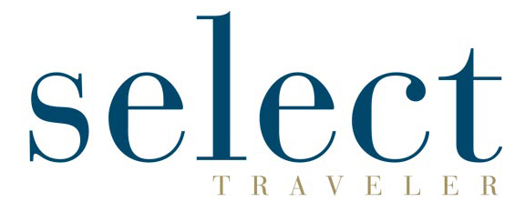](https://selecttraveler.com/)**

**SELECT TRAVELER**

*Value: $1,650 • Minimum Bid: $550*

**ITEM**:

1/3 page 4-color ad (must use by July 31, 2022)

***ABOUT SELECT TRAVELER****:*

*Select Traveler is America’s only magazine dedicated to upscale travel groups.  It is read 6 times per year by bank, alumni, and chamber travel planners.*

* *Circulation: 6,000+*
* *Distribution: National*
* *Subscriber Demographics: Planners for banks, chambers, and alumni travel groups*

*Kelly Tyner  
Vice President, Sales & Marketing  
The Group Travel Leader Inc.  
& Small Market Meetings  
859-334-1708*

[](https://www.simpleviewinc.com/)

**SIMPLEVIEW #1**

*Value: $4,000 • Minimum Bid: $1,300*

**ITEM**:

SEO Audit

**ITEM DETAILS**:

Simpleview's search engine optimization experts will conduct a comprehensive website review to identify any technical and non-technical issues that may be impeding the DMO's search engine rankings. This complex and comprehensive analysis will help to prioritize these issues to create a clear, actionable plan that is easy for the DMO to follow and implement.

Expires a year after the audit is awarded. To complete the audit, Simpleview must be granted access to the DMO's Google Analytics and Search Console accounts.

***ABOUT SIMPLEVIEW***:

Simpleview is the travel and tourism industry's leading provider of CRM, CMS, website design, search marketing, revenue generation, and mobile technologies for destination marketing organizations (DMOs). The company employs 300+ staff and works with more than 900 customers in North America and around the world.

[](https://www.simpleviewinc.com/)

**SIMPLEVIEW #2**

*Value: $1,000 • Minimum Bid: $300*

**ITEM**:

YEXT Digital Reputation & Listing License

**ITEM DETAILS**:

Yext is a listing syndication and reputation management digital marketing platform that gives you the power to ensure your business is consistently and accurately represented across the internet, in one convenient place. It stores the key information about your business and sends that information to over 100+ digital directories like Google My Business, Yahoo, Bing, Facebook, Tripadvisor, Google Maps, as well as voice search platforms like Apple’s Siri and Amazon Alexa. It also allows you to engage with your customers in near real-time through its reviews and reputation management platform.

As part of the auction, a member of the DTN staff will walk you, or the organization of your choice, through the onboarding process. We will educate you on the platform, work with you to make sure your information is accurate, and share some of the tips and tricks for tending to your digital footprint. Any license awarded through the auction will need to be onboarded within 3-weeks from the date of purchase. This is a 12-month license and the term will begin once the initial onboarding steps are completed.

***ABOUT SIMPLEVIEW****:*

*Simpleview is the travel and tourism industry's leading provider of CRM, CMS, website design, search marketing, revenue generation, and mobile technologies for destination marketing organizations (DMOs). The company employs 300+ staff and works with more than 900 customers in North America and around the world.*

**[](https://smallmarketmeetings.com/)**

**SMALL MARKET MEETINGS**

*Value: $1,435 • Minimum Bid: $400*

**ITEM**:

1/3 page 4-color ad *(must use by July 31, 2022)*

***ABOUT SMALL MARKET MEETINGS****:*

*Small Market Meetings is the only meetings industry publication that exclusively covers smaller destinations in every issue and is the official publication of the Small Market Meetings Conference.*

* *Circulation: 10,500*
* *Distribution: National*
* *Subscriber Demographics: Meeting Planners*

*Kelly Tyner  
Vice President, Sales & Marketing  
The Group Travel Leader Inc.  
& Small Market Meetings  
859-334-1708*

[](https://www.smithsonianmag.com/)

**SMITHSONIAN MEDIA**

*Value: $8,450 • Minimum Bid: $1,200*

**ITEM**:

Daily enewsletter takeover (to run in 2021)

**ITEM DETAILS**:

Coverage of new discoveries, scientific breakthroughs and cultural analysis; extended features from Smithsonian magazine and exclusive features from Smithsonian.com. 300,000 Opt-in Subscribers; deploys weekdays

***ABOUT SMITHSONIAN MEDIA****:  
Smithsonian Media exists for the sole purpose of increasing and diffusing knowledge. We are boundless in our expression across platforms and our topic areas are limitless.*

*Jaime Duffy*

*Travel Sales Director*

[*Duffyj2@si.edu*](mailto:Duffyj2@si.edu)

*Cell: 973-760-3739*

[](https://www.smliv.com/)

**SMOKY MOUNTAIN LIVING MAGAZINE**

*Value: $845 • Minimum Bid: $400*

**ITEM**:

1/3-page ad (expires 6/30/2022)

***ABOUT SMOKY MOUNTAIN LIVING****:*

*Smoky Mountain Living is a bi-monthly regional magazine embracing the history, culture and outdoors of the Southern Appalachian Mountains. There are 40,000 copies of SML nationally distributed either by paid subscribers or newsstand sales. SML is in major retailers (Publix, Ingles, Barnes & Noble, etc.) from Ohio to Tampa.*

*Circulation 35,000 copies; paid subscribers and newsstand sales. Readers who love the mountains; Mid-Atlantic/Southern States*

*Lisa L. Williams*

*Advertising Sales Rep*

*Smoky Mountain Living Magazine/Blue Ridge Motorcycling Magazine  
865-742-4388 - cell*[*lisa.w@smliv.com*](mailto:lisa.w@smliv.com)[*facebook.com/smokymtnliving*](http://facebook.com/smokymtnliving)[*twitter.com/smokymtnliving*](http://twitter.com/smokymtnliving)

[](https://www.sojern.com/)

**SOJERN**

*Value: $5,000 • Minimum Bid: $1,500*

**ITEM**:

1 month CPM campaign

**ITEM DETAILS**:

* Winning bidder will be required to sign an IO reflecting IAB 3.0 terms and conditions (standard).
* Must be a separate campaign and cannot be combined with any other campaign, offer, or program.
* Campaign must run between now and 12/31/2021.
* Campaign must run no more than 30 days.
* Client must provide final creative assets at least 5 days prior to campaign launch.
* Creative swaps are not allowed.
* Campaign is applicable to one of the following products reflecting these rates and impressions:
  + Display: $6 CPM 833,333 impressions
  + Pre-Roll Video: $16 CPM 312,500 impressions
  + Native: $7.50 CPM 666,667 impressions
* Winning bidder can add additional investment to the campaign and extend dates ($5,000 min per month).
* Winning bidder to be confirmed to Sojern by KTIA.

***ABOUT SOJERN****:*

*Sojern ingests and analyzes billions of live search and purchase signals from travel websites all over the world then we curate it through our industry leading platform to form hyper-targeted travel audiences.*

*Utilizing programmatic ad technology, we use these audiences to target travelers through multi-channel digital marketing campaigns to drive direct bookings for our clients in real time, at scale, in any market.*

*Guy Miller*

*Senior Sales Director*

[*guy.miller@sojern.com*](mailto:guy.miller@sojern.com)

*770-318-5356*

[](https://www.spectrumreach.com/)

**SPECTRUM REACH**

*Value: $1,500 • Minimum Bid: $600*

**ITEM**:

4-week cable package (250 commercials – Lexington or Louisville DMA or 500 commercials in one Lexington or Louisville zone)

**ITEM DETAILS**:

*DMA includes households with Spectrum Cable and DirectTV.

**Zone only includes Spectrum Cable in portion of DMA.

Schedule will be built utilizing our Audience App software targeting consumers interested in traveling.

***ABOUT SPECTRUM REACH****:*

*Nothing drives awareness like the power of TV. Your audiences are watching their favorite programs now more than ever, making TV the #1 brand builder and marketing tool. With the best shows across the top 60+ cable networks, it’s easy to connect with your target audience in the content they love most wherever and whenever they’re watching. Spectrum Reach’s marketing services go beyond what traditional advertising products can provide, delivering magnified metrics for our clients, precise audience targeting, and real-time planning. Get your message on the most effective marketing tool today.*

*Kim Wade | Account Executive | Advertising*

*P 859-422-1529 | C 859-537-4739*

[*Kimberly.Wade@charter.com*](mailto:Kimberly.Wade@charter.com)

**[](https://grouptravelleader.com/)**

**THE GROUP TRAVEL LEADER**

*Value: $2,000 • Minimum Bid: $650*

**ITEM**:

1/3 page 4-color ad (must use by July 31, 2022)

***ABOUT THE GROUP TRAVEL LEADER****:*

*The Group Travel Leader is the national magazine for the group travel industry and is read by more than 15,000 professional tour operators and volunteer travel partners.  It is published 10 times per year and covers destinations, trends and industry news.*

* *Circulation: 15,000+*
* *Distribution: National*
* *Subscriber Demographics: Travel Planners for groups of all ages and sizes*

*Kelly Tyner  
Vice President, Sales & Marketing  
The Group Travel Leader Inc.  
& Small Market Meetings  
859-334-1708*

[](https://www.lanereport.com/)

**THE LANE REPORT**

*Value: $2,160 • Minimum Bid: $750*

**ITEM**:

1/2 page horizontal advertisement.

(The ad needs to be Bleed W 8.125" H 5.25" or Non-Bleed H 7" H 4.875)

***ABOUT THE LANE REPORT****:*

*The Lane Report’s magazine and digital communications reach the state’s top leaders in business, economic development, and public policy, who depend on The Lane Report to keep them informed of the latest business news across Kentucky.*

*Jake Kratzenberg*

*Chief Operating Officer*

*The Lane Report, Inc.*

[*859-244-3500*](tel:859-244-3500)*|* [*859-270-9894*](tel:859-693-3200)

[*jake@lanereport.com*](mailto:jake@lanereport.com)

[*www.lanereport.com*](https://www.lanereport.com/)

[](https://www.oxfordamerican.org/)

**THE OXFORD AMERICAN**

*Value: $900 • Minimum Bid: $250*

**ITEM**:

(1) 1/2 mo. 300x600 banner ad on [www.oxfordamerican.org](http://www.oxfordamerican.org) (To be used by April 2022)

***ABOUT THE OXFORD AMERICAN****:*

*The Oxford American explores and celebrates the complexity and vitality of the American South through exceptional writing, music, and culinary and visual arts.*

*Kathleen King*[*kking@oxfordamerican.org*](mailto:kking@oxfordamerican.org)

*Kelsey White*[*kwhite@oxfordamerican.org*](mailto:kwhite@oxfordamerican.org)

**[](https://www.travelhost.com/lexington)**

**TRAVELHOST OF THE BLUEGRASS**

*Value: $1,300 • Minimum Bid: $500*

**ITEM**:

1/3 page ad

**ITEM DETAILS**:

No restrictions, if current advertiser purchases the donation, the space will be added to their current agreement; deadline is 90 days prior to publication date.

***ABOUT TRAVELHOST OF THE BLUEGRASS****:*

*The #1 Tourism Magazine in the Bluegrass!  www.travelhost.com/bluegrass*

*Eli Mertens*

*Publisher/President*

*TravelHost of the Bluegrass*

*(859) 351-6728*

[*eli@travelhost.com*](mailto:eli@travelhost.com)

**[](https://www.wkyt.com/)**

**WKYT #1**

*Value: $2,500 • Minimum Bid: $800*

**ITEM**:

250,000 ads on wkyt.com

*Jaime Sayre Kawaja*

*General Sales Manager*

*WKYT-TV, CW,*[*wkyt.com*](http://wkyt.com)

*Lexington, KY*

*Direct: 859.566.1294*

[*jkawaja@wkyt.com*](mailto:jkawaja@wkyt.com)

**[](https://www.wkyt.com/)**

**WKYT #2**

*Value: $1000 • Minimum Bid: $300*

**ITEM**:

Native ad on wkyt.com

*Jaime Sayre Kawaja*

*General Sales Manager*

*WKYT-TV, CW,*[*wkyt.com*](http://wkyt.com)

*Lexington, KY*

*Direct: 859.566.1294*

[*jkawaja@wkyt.com*](mailto:jkawaja@wkyt.com)

**[](https://www.wkyt.com/)**

**WKYT #3**

*Value: $500 • Minimum Bid: $150*

**ITEM**:

eBlast to go out to 70,000 people who opt in WKYT’s offers list

*Jaime Sayre Kawaja*

*General Sales Manager*

*WKYT-TV, CW,*[*wkyt.com*](http://wkyt.com)

*Lexington, KY*

*Direct: 859.566.1294*

[*jkawaja@wkyt.com*](mailto:jkawaja@wkyt.com)