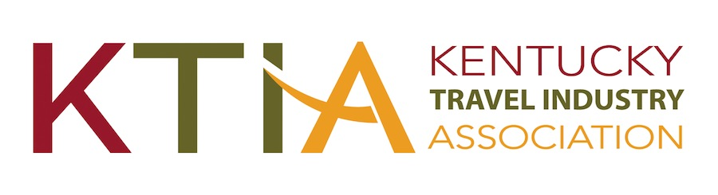
For more information, contact:
Hank Phillips, President/CEO at (502) 223-8687
Hank.Phillips@ktia.com
931 East Main Street
Frankfort, Kentucky 40601
Ph. (502) 223-8687

FOR IMMEDIATE RELEASE

Frankfort, KY, November 14, 2022

(Organization) Wins Prestigious Tourism Award(s)

(Organization) has received a (adapt for use for multiple awards) Traverse Award for Excellence in Tourism from the Kentucky Travel Industry Association. The award was presented during the 2022 Kentucky Travel Industry Annual Conference held November 9-11 at the Griffin Gate Marriott Golf Resort & Spa in Lexington.

(Organization) received a (Level(s)) Traverse for its (Name or description of entry). According to, (Organization’s spokesperson), “(Comments).”

Kentucky travel and tourism businesses and marketing organizations vie for Traverse Awards in 11 categories. The Traverse Awards are judged by a panel of out-of-state travel and tourism industry experts. Award criteria include concept, creativity, results and impact. A total of 160 entries were submitted from throughout Kentucky for the competition.

According to KTIA president & CEO Hank Phillips, ”This year’s Traverse Awards were marked by comments from our judges about the exceptional across the board quality of the entries. As tourism in Kentucky continues its recovery, it is apparent that the industry is stepping up with creative and results oriented strategies for capturing prospective visitors' attention and ultimately their decisions to visit the Commonwealth. These awards are a testament to the expertise of Kentucky's tourism professionals and reflect why tourism remains a major driver of Kentucky's economy."

The Kentucky Travel Industry Association represents and serves all segments of Kentucky’s tourism industry, which despite the pandemic’s severe impact, contributed $11.2 billion to Kentucky’s economy in 2021. The nearly 1000-member association engages in advocacy and provides its members with education, information and business development opportunities. The association also works to inform the public of the enormous economic, employment and tax revenue contributions tourism makes to the people of Kentucky.

